AI-ASSISTED CODING
ASSIGNMENT-3.1
Lab Experiment: Prompt Engineering – Improving Prompts
and Context Management
---------------------------------------
NAME: Adepu Goutham Sri Bhargav
HALL-TICKET: 2403A510C4
BATCH NO: 05

Task 1:
● Mobile Data Usage Billing Application:
Use Python programming and AI-assisted coding tools to create an
application that simulates mobile data billing for a telecom service
provider.
Prompt: Create an application that simulates mobile data billing for a telecom service
provider. Make the program realistic by taking reference to the actual data provider plans.
CODE: # Telecom Billing Simulator
# Assumptions (easily editable below):
# - Prepaid: tiered data pricing
# - Postpaid: first 20 GB included, then flat per-GB rate
# - Value-added services: fixed monthly fees
# - Tax: 18%
from dataclasses import dataclass
from typing import List, Tuple
TAX_RATE = 0.18 # 18% GST (edit as needed)
# Pricing configuration (edit to match your scenario)
PRICING = {
"prepaid": {
# slabs: (upper_limit_inclusive, rate_per_gb)
# applies from 0 upward; each slab covers its range
"slabs": [(2, 15.0), (10, 10.0), (float("inf"), 8.0)],
"included_gb": 0.0, # no free data
"plan_note": "Prepaid tiered data pricing",
},
"postpaid": {
# postpaid: first 20 GB free, then flat rate
"included_gb": 20.0,
"post_included_rate": 8.0, # ₹ per GB beyond included
"plan_note": "Postpaid: first 20 GB included, then ₹8/GB",
},
}
# Value-added services (edit or extend as needed)
SERVICES = {
"caller tune": 30.0,
"ott basic": 149.0,
"international roaming": 499.0,
"data rollover": 59.0,
}
@dataclass
class BillBreakdown:
plan_type: str
data_gb: float
data_lines: List[Tuple[str, float]] # (description, amount)
dc_total: float
vc_lines: List[Tuple[str, float]] # (service name, price)
vc_total: float
tax: float
total: float
notes: List[str]
def money(x: float) -> str:
return f"₹{x:,.2f}"

def calc_data_charges(plan_type: str, data_gb: float) -> Tuple[List[Tuple[str, float]], float, List[str]]:
pt = plan_type.lower()
lines = []
notes = []
if pt == "prepaid":
cfg = PRICING["prepaid"]
remaining = max(0.0, data_gb - cfg["included_gb"])
start = 0.0
total = 0.0
for upper, rate in cfg["slabs"]:
slab_width = min(remaining, upper - start)
if slab_width > 0:
amount = slab_width * rate
lines.append((f"{slab_width:.2f} GB @ {money(rate)}/GB", amount))
total += amount
remaining -= slab_width
start = upper
if remaining <= 1e-9:
break
notes.append(cfg["plan_note"])
return lines, total, notes
elif pt == "postpaid":
cfg = PRICING["postpaid"]
free_gb = min(data_gb, cfg["included_gb"])
billable = max(0.0, data_gb - cfg["included_gb"])
total = billable * cfg["post_included_rate"]
if free_gb > 0:
lines.append((f"{free_gb:.2f} GB included", 0.0))
if billable > 0:
lines.append((f"{billable:.2f} GB @ {money(cfg['post_included_rate'])}/GB", total))
notes.append(cfg["plan_note"])
return lines, total, notes
else:
raise ValueError("Invalid plan type. Use Prepaid or Postpaid.")

def calc_service_charges(selected_services: List[str]) -> Tuple[List[Tuple[str, float]], float, List[str]]:
lines = []
total = 0.0
notes = []
for s in selected_services:
key = s.strip().lower()
if not key:
continue
if key in SERVICES:
price = SERVICES[key]
lines.append((s.strip(), price))
total += price
else:
# Unknown services are ignored but noted
notes.append(f"Ignored unknown service: '{s.strip()}'")
return lines, total, notes
def generate_bill():
# --- Inputs ---
try:
data_gb = float(input("Enter Data Consumed (in GB): ").strip())
plan_type = input("Enter Plan Type (Prepaid/Postpaid): ").strip()
services_in = input("Additional Services (comma-separated, e.g., Caller Tune, OTT Basic): ").strip()
except Exception as e:
print("Input error:", e)
return
if plan_type.lower() not in ("prepaid", "postpaid"):
print("Invalid plan type. Please enter 'Prepaid' or 'Postpaid'.")
return
selected_services = [s for s in services_in.split(",")] if services_in else []
# --- Calculations ---
data_lines, dc_total, notes_dc = calc_data_charges(plan_type, data_gb)
vc_lines, vc_total, notes_vc = calc_service_charges(selected_services)
subtotal = dc_total + vc_total
tax = subtotal * TAX_RATE
total = subtotal + tax
breakdown = BillBreakdown(
plan_type=plan_type.title(),
data_gb=data_gb,
data_lines=data_lines,
dc_total=dc_total,
vc_lines=vc_lines,
vc_total=vc_total,
tax=tax,
total=total,
notes=[*notes_dc, *notes_vc, f"Tax rate: {TAX_RATE*100:.0f}%"],
)
# --- Output: Itemized Bill ---
print("\n" + "="*58)
print(" TELECOM ITEMIZED BILL")
print("="*58)
print(f"Plan Type: {breakdown.plan_type}")
print(f"Data Used: {breakdown.data_gb:.2f} GB")
print("-"*58)
print("Data Charges (DC):")
if breakdown.data_lines:
for desc, amount in breakdown.data_lines:
print(f" - {desc:<35} {money(amount):>12}")
else:
print(" - No data charges")
print(f"{'Subtotal DC':<40}{money(breakdown.dc_total):>18}")
print("\nValue-added Services (VC):")
if breakdown.vc_lines:
for svc, price in breakdown.vc_lines:
print(f" - {svc:<35} {money(price):>12}")
else:
print(" - None")
print(f"{'Subtotal VC':<40}{money(breakdown.vc_total):>18}")

print("-"*58)
print(f"{'Subtotal (DC + VC)':<40}{money(breakdown.dc_total + breakdown.vc_total):>18}")
print(f"{'Tax':<40}{money(breakdown.tax):>18}")
print("="*58)
print(f"{'TOTAL PAYABLE':<40}{money(breakdown.total):>18}")
print("="*58)
if breakdown.notes:
print("\nNotes:")
for n in breakdown.notes:
print(f" - {n}")
if __name__ == "__main__":
generate_bill()

OUTPUT:
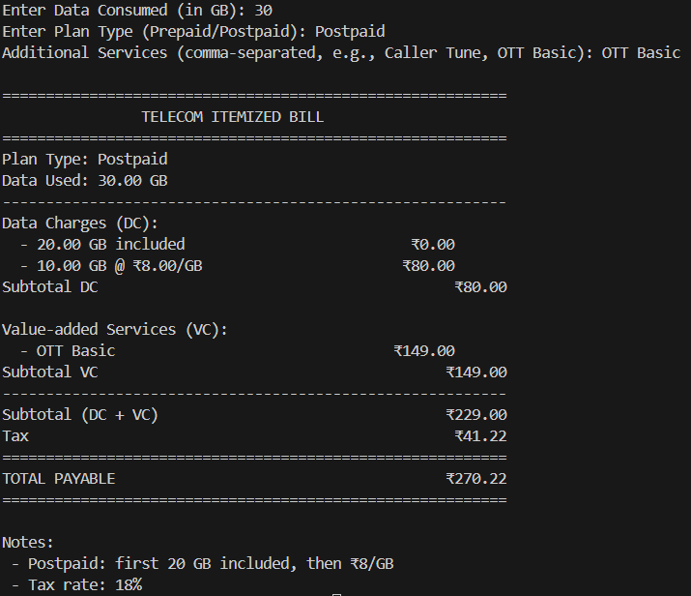

EXPLANATION:
The program simulates mobile data billing for a telecom provider. It takes three inputs from the user:
- Data consumed (in GB)
- Plan type (Prepaid or Postpaid)
- Additional services used (e.g., caller tune, OTT subscription)
Billing logic:
- Calculates Data Charges (DC) based on plan:
  - Prepaid uses tiered per-GB rates.
  - Postpaid includes free data (20 GB), then charges per GB.
- Adds Value-added Charges (VC) for extra services (fixed rates).
- Applies tax (e.g., 18%) on the subtotal.
Output:
- Displays an itemized bill showing plan details, data usage and charges, service charges, tax, and total payable amount.
- Notes about included benefits or ignored inputs are also displayed.

--------------------------------------------------------------------------------------------------------------
Task 2: Develop an LPG Billing System (1.0 Marks)
Objective:
Apply your Python programming skills and utilize AI-assisted coding tools to build an application that calculates the LPG bill based on specified customer inputs and billing parameters.
Prompt: Help me build an application that calculates the LPG bill based on specified customer inputs and billing parameters.

CODE:
import random
# Price list for LPG cylinders
LPG_PRICES = {
"domestic 14.2 kg": 905.00,
"domestic 5 kg": 335.50,
"commercial 19 kg": 1886.50,
"commercial 47.5 kg": 4712.00,
}
def calculate_lpg_bill(cylinder_type, quantity, subsidy, delivery_charge):
# Get the price per cylinder
cylinder_type_lower = cylinder_type.strip().lower()
if cylinder_type_lower not in LPG_PRICES:
raise ValueError("Invalid cylinder type entered.")
price_per_cylinder = LPG_PRICES[cylinder_type_lower]
# Base amount before subsidy and delivery
base_amount = price_per_cylinder * quantity
# Subsidy applies only to domestic cylinders
subsidy_amount = subsidy if "domestic" in cylinder_type_lower else 0.0
# Final bill calculation
total_amount = base_amount - subsidy_amount + delivery_charge
# Prepare itemized details
bill_details = {
"Cylinder Type": cylinder_type.title(),
"Number of Cylinders": quantity,
"Price per Cylinder": price_per_cylinder,
"Base Amount": base_amount,
"Subsidy": subsidy_amount,
"Delivery Charges": delivery_charge,
"Total Bill": total_amount
}
return bill_details
def main():
# User inputs
cylinder_type = input("Enter Cylinder Type (Domestic 14.2 kg / Domestic 5 kg / Commercial 19 kg / Commercial 47.5 kg): ")
quantity = int(input("Enter Number of Cylinders Booked: "))
subsidy = float(input("Enter Subsidy Amount (if applicable, else 0): "))
# Delivery charge (random between 10 and 50 or could be fixed)
delivery_charge = random.randint(10, 50)
# Calculate bill
try:
bill = calculate_lpg_bill(cylinder_type, quantity, subsidy, delivery_charge)
# Display itemized bill
print("\n====== LPG BILL ======")
print(f"Cylinder Type : {bill['Cylinder Type']}")
print(f"Number of Cylinders : {bill['Number of Cylinders']}")
print(f"Price per Cylinder : ₹{bill['Price per Cylinder']:.2f}")
print(f"Base Amount : ₹{bill['Base Amount']:.2f}")
print(f"Subsidy : -₹{bill['Subsidy']:.2f}")
print(f"Delivery Charges : ₹{bill['Delivery Charges']:.2f}")
print("-----------------------------")
print(f"Total Bill Amount : ₹{bill['Total Bill']:.2f}")
print("=============================\n")
except ValueError as e:
print("Error:", e)
if __name__ == "__main__":
main()
Output:
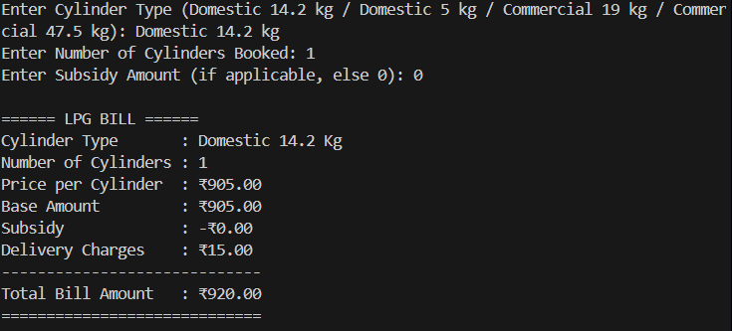
EXPLANATION:
The program calculates an LPG bill based on customer inputs. It takes:
- Cylinder type (Domestic 14.2 kg / Domestic 5 kg / Commercial 19 kg / Commercial 47.5 kg)
- Number of cylinders booked
- Subsidy amount (applies only to domestic cylinders)
Billing logic:
- Uses a fixed price list for each cylinder type.
- Calculates base amount = price per cylinder × quantity.
- Subtracts subsidy for domestic bookings.
- Adds delivery charges (random between ₹10–₹50).
Output:
- Displays an itemized bill including cylinder type, quantity, price per cylinder, base amount, subsidy, delivery charges, and the total bill amount.

